Anger Resources
BOOKS:
Atlas of the Heart, Chapter 12 – Places We Go When We Feel Wronged, Brené Brown

Coping With Your Anger, A Christian Guide by Andrew D Lester

The Myth of Normal, Chapter 26 – Four A’s and Five Compassions: Some Healing Principles – pgs.377-380 (Anger), Gabor Mate

BLOGS:

https://www.gottman.com/blog/the-anger-iceberg/
https://www.gottman.com/blog/the-dark-side-of-anger-what-every-couple-should-know/
https://www.gottman.com/blog/handle-anger-relationship/
https://www.gottman.com/blog/helping-little-ones-big-emotions/
https://www.gottman.com/blog/why-we-need-to-stop-playing-the-blame-game/

VIDEOS:

https://www.youtube.com/watch?v=Yh1-y3TzSO4

Dr. Gabor Maté on How to Process Anger and Rage | The Tim Ferriss Show

https://www.youtube.com/watch?v=QG4Z185MBJE

Anger, Compassion, and What It Means To Be Strong | Russell Kolts | TEDxOlympia
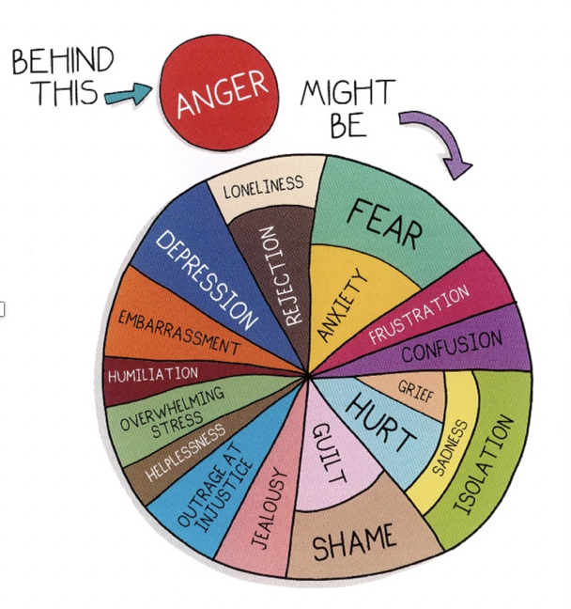
Graphic from Atlas of the Heart page 222 – Brené Brown Whole hearted School Couseling.

